ANSWER KEY SUBMISSION
Date of Exam & Session | 16/11/2022 & FN | Category of Exam | CLA3
Course Name | Artificial Neural Networks | Course Code | 18CSE388T
Name of the Faculty submitting | Ms.P.Vidyasri | Date of submission of Answer Key | 18/98/2022
Department to which the faculty belongs to | CSE | Total Marks | 50
PART - A (10x1 = 10)
ANSWER ALL THE QUESTIONS
Q.No | Questions | Marks
1 | How many layer(s) an RBF network has?  a) One layer  b) Two layers  c) Three layers  d) Zero layer | 1
2 | Choose standard propagation and activation functions of RBF networks for the output layer.  a) Weighted sum, identity  b) Identity, weighted sum  c) Weighted sum, radial basis function  d) Radial basis function, weighted sum | 1
3 | Identify which technique is most complex to determine cluster centers and widths in RBFNN?  a) SOM  b) K-means clustering  c) Adaptive to learning process  d) Fixed selection of centers and widths with even spacing | 1
4 | Which layer is also called as RBF?  a) Input layer  b) Output layer  c) Hidden layer  d) Recognition layer | 1
5 | Examine what is not true about recurrent backpropagation?  a) Also called backpropagation through time  b) Uses unfolding  c) Uses teacher forcing  d) Uses many epochs | 1
6 | Identify why does SOM network stiffen with the passage of time?  a) Because learning rates and neighborhoods are decreased over time  b) Because training examples get exhausted  c) Because no new neurons are added  d) Because no weight adjustment happens in SOM | 1
7 | What is the objective of feature maps?  a) To capture the features in space of input patterns  b) To capture just the input patterns4  c) Update weights  d) To capture output patterns | 1
8 | What is the main benefit of ART networks?  a) Unsupervised learning  b) Attain both stability and plasticity  c) Attain stability without plasticity  d) Attain plasticity without stability | 1
9 | Judge SOM and ART.  a) Both are examples of unsupervised learning  b) Only SOM is example of unsupervised learning  c) Only ART is an example of unsupervised learning  d) Neither are examples of unsupervised learning | 1
10 | Which of the ART network improves the learning ability by implementing biological process?  a) ART-1  b) ART-2  c) ART-3  d) ART-4 | 1

PART - B (4x4= 16)
ANSWER ALL THE QUESTIONS
Q.No | Questions | Marks
11 | Why Moore-Penrose pseudo inverse is used in system of equations?  To solve the system of equations, we have to find the solution M of a matrix multiplication T=M.G  The problem is that this time we cannot invert the |P|x|H| matrix M because it is not a square matrix (here,|P| not equal to |H| is true).  Here, we have to use the Moore-Penrose pseudo inverse M ⁺ which is defined by  M⁺ =(M^{T}.M)⁻¹.M^{T} | 4
12 | Compare RBF networks and multilayer perceptron.  - Input dimension  - Center selection  - Output dimension  - Extrapolation  - Lesion tolerance  - Spread | 4
13 | Define Elman network with diagram.  The Elman networks is an MLP have context neurons, too, but one layer of context neurons per information processing neuron layer.  The outputs of each hidden neuron or output neuron are led into the associated context layer and from there it is reentered into the complete neuron layer during the next time step. Compared with Jordan networks the Elman networks often have the advantage to act more purposeful since every layer can access its own context. | 4
14 | Evaluate why SOMs activate the neuron with least distance to on an input pattern?  - Input of an arbitrary value p of the input space R^{N}.  - Calculation of the distance between every neuron k and p by means of a norm, i.e. calculation of ||p − c_{k}||.  - One neuron becomes active, namely such neuron i with the shortest calculated distance to the input.  - All other neurons remain inactive. This paradigm of activity is also called winner-takes-all scheme. | 4
15 | Elaborate competitive learning in SOM.  A form of unsupervised training where output units are said to be in competition for input patterns. During training, the output unit that provides the highest activation to a given input pattern is declared the weights of the winner and is moved closer to the input pattern, whereas the rest of the neurons are left unchanged This strategy is also called winner-take-all since only the winning neuron is updated. | 4
16 | Discuss the structure of ART network.  An ART network comprises exactly two layers:  - the recognition layer ‘O’  - the input layer ‘I’  - with the input layer being completely linked towards the recognition layer.  - This complete link induces a top-down weight matrix W that contains the weight values of the connections between each neuron in the input layer and each neuron in the recognition layer. | 4
PART - C (2x12 = 24)
ANSWER THE QUESTIONS
Q.No | Questions | Marks
17(a) | Explain in detail about the training of recurrent networks with suitable diagram.  - Jordan network without a hidden neuron layer for our training attempts so that the output neurons can directly provide input.  - This approach is a strong simplification because generally more complicated networks are used.  - But this does not change the learning principle.  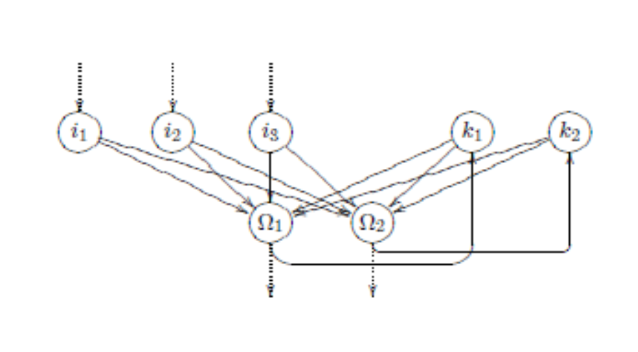  Unfolding in time:  - The back propagation of error, which back propagates the delta values.  - In recurrent networks the delta values would back propagate cyclically through the network again and again, which makes the training more difficult.  - We cannot know which of the many generated delta values for a weight should be selected for training, i.e. which values are useful.  - We cannot definitely know when learning should be stopped.  - The advantage of recurrent networks is great state dynamics within the network.  - One learning approach would be the attempt to unfold the temporal states of the network.  - Recursions are deleted by putting a similar network above the context neurons.  - We have to backtrack the recurrences and place "‘earlier"’ instances of neurons in the network thus creating a larger, but forward-oriented network without recurrences.  - This enables training a recurrent network with any training strategy developed for non-recurrent ones.  - Here the input is entered as teaching input into every "copy" of the input neurons.  - This can be done for a discrete number of time steps.  - These training paradigms are called unfolding in time | 6  6
17(b) | How is information processed in an RBF Network? Explain with the help of 2-5-3 RBF network.  - An RBF network receives the input by means of the unweight connections.  - Then the input vector is sent through a norm (to provide positive value) so that the result is a scalar.  - This scalar is processed by a radial basis function (Gaussian bells).  - The output values of the different neurons n of the RBF layer or of the different Gaussian bells are added within the third layer basically, in relation to the whole input space, Gaussian bells are added here.  - Suppose that we have a second, a third and a fourth RBF neuron and therefore four differently located centers.  - 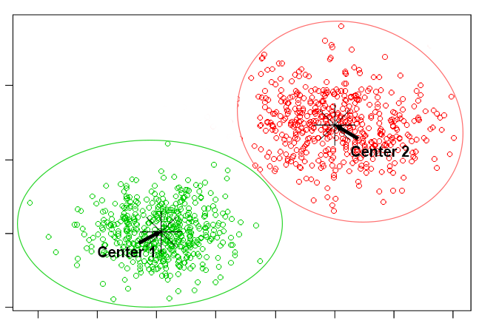  - Each of these neurons now measures another distance from the input to its own center and de facto provides different values, even if the Gaussian bell is the same.  - Since these values are finally simply accumulated in the output layer, one can easily see that any surface can be shaped by dragging, compressing and removing Gaussian bells and subsequently accumulating them.  - Here, the parameters for the superposition of the Gaussian bells are in the weights of the connections between the RBF layer and the output layer.  - Furthermore, the network architecture offers the possibility to freely define or train height and width of the Gaussian bells – due to which the network paradigm becomes even more versatile. | 9  3
8(a) | Examine and explain in detail about the variations of SOMs.  A neural gas is a SOM without a static topology:  - Neural gas is an artificial neural network, inspired by the self-organizing map and introduced in 1991 by Thomas Martinetz and Klaus Schulten.  - The neural gas is a type of self-organizing map that was created to solve the challenge of mapping complex input data that occurs only in subspaces of the input space or even alters the subspace.  - In a nutshell, the goal of a neural gas is to create a SOM without a grid framework.  - A truly dynamic neighborhood function distinguishes a neural gas from a SOM.  A Multi-SOM consists of several separate SOMs:  - What should we do with input patterns that are known to be limited to a few (perhaps discontinuous) areas?  - Here, the idea is to use not only one SOM but several ones.  - A multi-self-organizing map, shortly referred to as M-SOM.  - A multiSOM is nothing more than the simultaneous use of M SOMs.  - This learning process is analog to that of the SOMs.  A multi-neural gas consists of several separate neural gases:  - Analogous to the multi-SOM, we also have a set of M neural gases.  - Basically, this is correct, but a multi-neural gas has two serious advantages over a simple neural gas. | 4  4  4
18(b) | List and discuss about the learning process and extensions of an ART network.  - It is divided to top-down and bottom-up learning.  - The two-piece learning procedure of the theory: On the one hand we train the top-down matrix W, on the other hand we train the bottom-up matrix V.  Pattern input and top-down learning:  - When a pattern is entered into the network it causes - an activation at the output neurons and the strongest neuron wins.  - Then the weights of the matrix W going towards the output neuron are changed such that the output of the strongest neuron Ω is still enhanced.  Resonance and bottom-up learning:  - The training of the backward w eights of the matrix V is a bit tricky.  - Only the weights of the respective winner neuron are trained towards the input layer and our current input pattern is used as teaching input. Thus, network is trained to enhance input vectors.  Adding an output neuron  - It's possible that the neurons are equally active or that many neurons are triggered, resulting in a network that is undecided.  - In this case, the control neurons' methods activate a signal that causes a new output neuron to be inserted.  Extensions:  - The ART networks have often been extended.  - ART-2 is extended to continuous inputs and additionally offers (in an extension called ART-2A) enhancements of the learning speed which results in additional control neurons and layers.  - ART-3 improves the learning ability of ART-2 by adapting additional biological processes such as the chemical processes within the synapses. | 9  3

HOD/CSE

